

WinLock User Guide Appendix
Opening Simlocks

Copyright © 1998 by Nokia Mobile Phones

Change History:

VERSION | STATUS | DATE | AUTHOR
V3 |  | 24-Apr-98 | Kalle Toivonen
Description | Extended GID field hanling. User is able to set the used length of GID fields.
V2 |  | 2-Mar-98 | Kalle Toivonen
Description | SimLock open password file handling added.
V1 |  | 2-Jan-98 | Kalle Toivonen
Description | First version.
- CONTENTS
1. GENERAL
1.1 Scope of This Document
2. INTRODUCTION
2.1 WinLock Environment
2.1.1 TDB-4 Operator Security Box
2.1.2 PKD-1SA+ dongle
3. SETTING UP WINLOCK
3.1 WinLock -> Options menu
3.2 WinLock -> Default menu
4. USING WINLOCK
4.1 WinLock main window
4.1.1 Opening SimLock
4.1.2 Calculating SimLock open passwords
4.1.3 SimLock open password -file handling
4.1.3.1 Input file format
4.1.3.2 Output file format
4.2 Error messages

GENERAL

Scope of This Document
This document is additional part to WinLock User Guide. It includes all additional items which are needed when performing SimLock opening or SimLock opening password calculation operations with WinLock. All other documentation can be found from WinLock Users guide.

Introduction

WinLock Environment
This chapter explains what is needed to open SimLocks and Calculating open passwords

TDB-4 Operator Security Box
This hardware is needed for opening SimLocks of some certain types of Nokia phones. More information about this you can get from your WinLock support.

If you have this hardware you will connect it to you PC’s sCOM (serial) port with standard RS232 cable.

NOTE: You are not able to use TDB-4 OPERATOR security box in Windows NT environment

NOTE: PKD-1SA+ DONGLE IS NEEDED WHEN USING TDB-4 OPERATOR SECURITY BOX.

PKD-1SA+ dongle
This hardware supports SimLock opening and SimLock open password calculation for all Nokia phone types which are supported by WinLock. See release note README.TXT -file.

NOTE: You must have PKD-1SA+ if you are using TDB-4 Operator Security Box.

NOTE: PKD-1SA dongle supports SimLock opening and SIMLOCK OPEN password calculation only for some older Nokia phone types. You can’t use it with TDB-4 security box.

Setting up winlock
This chapter includes what set up values and parameters WinLock contains concerning SimLock opening.

WinLock -> Options menu

Remember to turn on Use TDB-4 Security Box check box and select correct COM port for it.

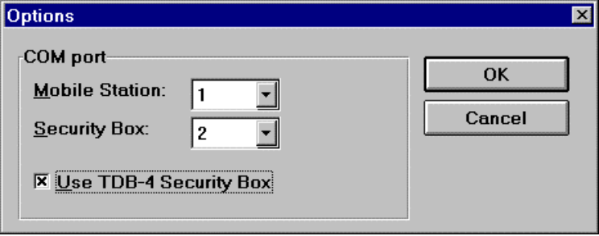

WinLock -> Default menu

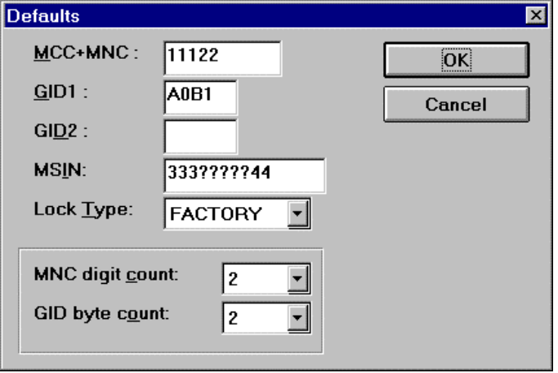

For SimLock level 2 and 3 unlocking it is very important to set correct value to GID byte count field. More information see WinLock User guide chapter WinLock->Defaults menu.

NOTE: IF YOU DON’T USE SIMLOCK LEVEL 2 OR 3, GID byte count DOES NOT HAVE ANY IMPORTANCE TO YOU. OTHERWISE IT IS VERY IMPORTANT TO KNOW WHAT IS THE LENGTH OF YOUR GID FIELD USED FOR SIMLOCKING. IF YOU HAVE ANY DOUBTS ABOUT THIS PLEASE CONTACT YOUR LOCAL SIMLOCK SUPPORT.

USING WINLOCK
This chapter explains all the components of WinLock windows and what you can do with WinLock and how. See also same chapter from WinLock User Guide.

WinLock main window

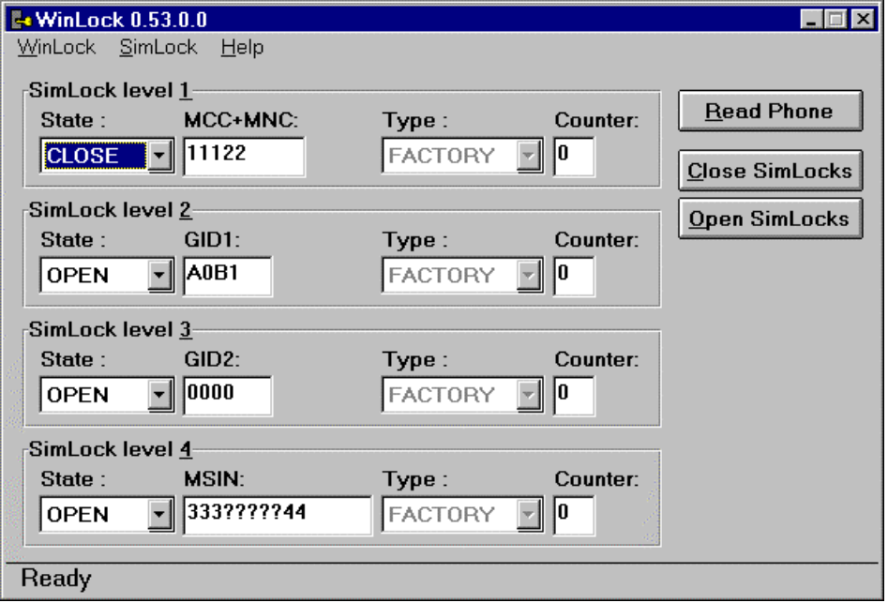

Opening SimLock

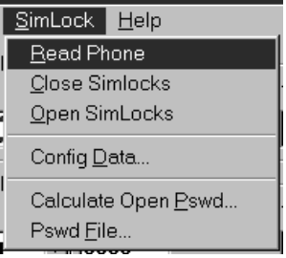

Click Open SimLocks command button in the Main window or select SimLock->Open SimLocks menu item. After you have started WinLock and perform first SimLock open operation password for opening is requested. Type of password can vary from product to product. Your local WinLock support will provide needed passwords to you.

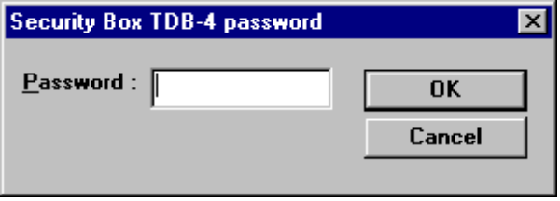

NOTE: THIS PASSWORD IS CALLED TDB-4 PASSWORD.
This password is totally different than for example simlock closing password for WinLock and it is needed only for opening SimLocks with TDB-4 security box and WinLock.

NOTE: BE ALWAYS CAREFUL WHILE ENTERING PASSWORDS.

All the SimLocks from the phone which is currently connected are opened. After the operation the current values from the phone are displayed on the screen. If the operation was succesful message “SimLock opened” is displayed on the status bar.

Calculating SimLock open passwords
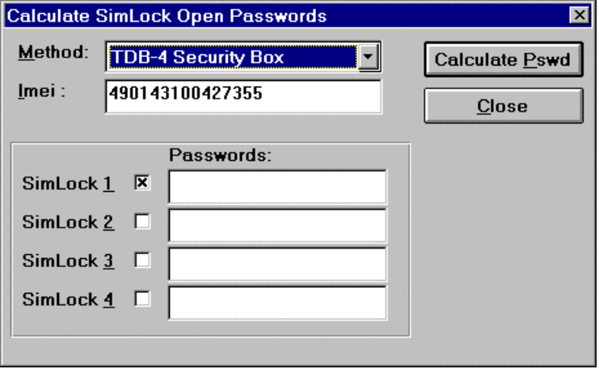

To perform this operation you don’t need to have phone currently connected into your PC. In this case you get an error message (message text depends on your configuration) which refers that WinLock was not able to read phone but you can ignore this message.

When calculating SimLock open password there are couple of different methods how this password can be calculated. This method vary from phone type to another. If you don’t know which method you should use, contact WinLock support.

IMEI is always needed for calculating SimLock open password. Enter IMEI without any separator characters (such as ‘/’). If you had phoned connected when you opened this dialog, IMEI value is read from that. You can still edit this value. Also you can connect new phone to your PC and read IMEI value from it while you have this dialog open. See chapter Reading SimLock values

Then simply turn on the check box for that SimLock level where you need the SimLock open password for. Also fill SimLock level specific information in the WinLock main window. This information is needed when calculating correct passwords. You can edit these values from the main window while you have this dialog open. You can read these values also from the phone which is currently connected. See chapter Reading SimLock values

NOTE: THIS IS MODELESS DIALOG. IT MEANS YOU CAN EDIT WINLOCK MAIN WINDOW FIELD VALUES OR PRESS READ PHONE BUTTON WHILE YOU HAVE THIS DIALOG OPEN:

NOTE BOTH IMEI AND CORRECT SIMLOCK SPECIFIC INFORMATION IS NEEDED TO CALCULATE CORRECT SIMLOCK OPEN PASSWORD.

SimLock open password -file handling
In WinLock you have possibility calculate SimLock open password by using files. Needed input is stored into input file which have a specific format. All open passwords are calculated and together with input information they are written into output file.

You can start this function by selecting SimLock->Pswd File... menu item. CreatePassword File dialog will be opened.

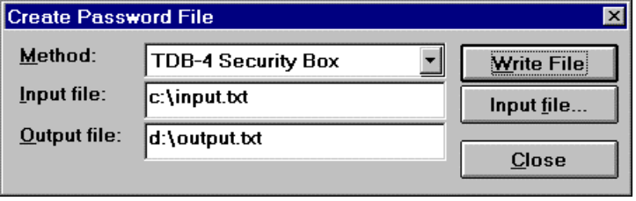

Select SimLock open password calculation method. More information about Method can be found from the chapter Calculating SimLock open passwords. After that enter Input and Output file names with full path. You can browse needed Input file by clicking command button Input file.... Standard Open file dialog is opened.

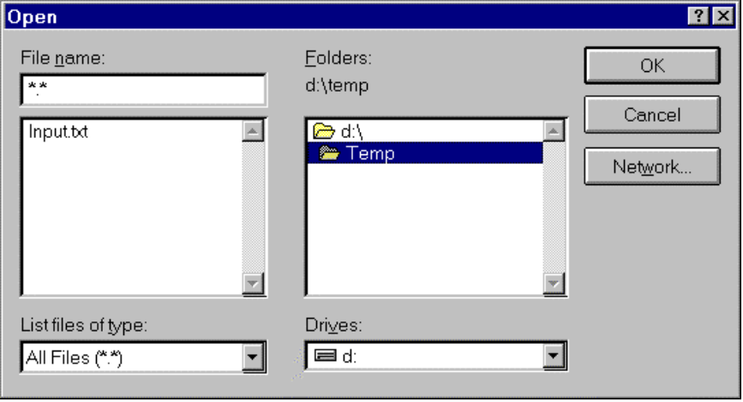

Find correct file, select it, click OK button. The name and full path of selected file will appear into Input file field.

After you have filled file name and path field, just click Write File button and output file is created.

Input file format
File format is the same than it was in the old MS-DOS based SimLock PC-software.

The input file consists of a file header and the input data. The header is Simlock_Input_V0.1. Where the end describes the input file version, currently 0.1. If the header is incorrect an error message is displayed. The input data is tab or space delimited in the order described in the example below. Data fields are interpreted in this order, an invalid or missing value is skipped. No password is though calculated when the necessary data is missing or invalid thus no error message is generated. If the line contains enough data to calculate at least one lock open password, it is calculated. In this way one can select which lock open passwords are calculated. If WinLock was unable to calculate password, password field is replaced with ‘?’ characters.

Note: The interpretation order must always be followed and thus fields that are not needed must be filled with garbage (e.g. text). Only the last fields can be left out totally. (IMEI is always needed).

Simlock_Input_V0.1
imei<tab>imsi<tab>gid1<tab>gid2
imei<tab>imsi<tab>gid1<tab>gid2
.
.
Example:
Simlock_Input_V0.1
123456789012345 123456789012345 ffff ffff

Output file format
File format is same than it was in old MS-DOS based SimLock PC-software.

Output file consists of a file header and the output data. The header is Simlock_Output_V0.1. Where the end describes the output file version, currently 0.1. The output data is tab delimited in the order described in the example below. When data fields contained invalid values or where missing default values are displayed in these fields, no password is calculated and the current password field is filled with ‘?’ characters.

Simlock_Output_V0.1
imei<tab>imsi<tab>gid1<tab>gid2<tab>L1<tab>password<tab>...<tab>L4<tab>password
imei<tab>imsi<tab>gid1<tab>gid2<tab>L1<tab>password<tab>...<tab>L4<tab>password
.
.
Example:
Simlock_Output_V0.1
123456789012345 123456789012345 ffff ffff L1 1234567890 L2 1234567890 L3 1234567890 L4 1234567890 (this is single line in the output file)

Error messages
Error messages which are related only to opening SimLocks are described here.

Message | Possible explanations
“File could not be opened” | - File did not exist or format was invalid. Check file name and path and format.
“Lock was already open” | - You tried to open SimLock but it was already open.
“Lock open password incorrect” | - If you tried to open SimLock level 2 or 3 check the WinLock->Defaults menu and the GID byte length. Ensure from WinLock support what is the value you should use.  - WinLock tried to open phone with incorrect password. Contact WinLock support.

